VISTA

Patch Module 2.5
User Manual: Patch Verifiers
September 2014
prepared for



by

©Copyright 2014 by VISTA Expertise Network. Licensed under Creative Commons Attribution-ShareAlike 4.0 International. Details are available at http://creativecommons.org/licenses/by-sa/4.0/
Revision History
Date | Description | Language | Authors
September 2014 | OSEHRA Version 2.5 release | English (US) | Kathy Ice and Frederick D.S. Marshall

(Table of Contents goes here)

Orientation
This manual is one of four user manuals for version 2.5 of the Patch Module. There is a different user manual for each essential role associated with the Patch Module; this manual is for patch verifiers.
If you are not sure whether or not you are a patch verifier, you probably are not. Patch verifier is a very specific role, and somebody would have mentioned it to you.
If you will be evaluating patches that have been released, to determine whether those patches will be installed at your organization, you are performing a step that is part of secondary development. Please consult the User Manual for Secondary Developers.
The Patch Module documentation suite:
Release Notes
Value Proposition
Installation Guide
User Manual: Primary Developers
User Manual: Secondary Developers
User Manual: Verifiers
User Manual: Patch Subscribers
Technical Manual
Security and Privacy Manual

Introduction
The Patch Module, as the name implies, is a software package that allows users and developers to create, revise, distribute, review, and receive software patches and updates for VistA. Options are provided for systematic entry, revision, and review of patches by developers, review and release of patches by verifiers, and display and distribution of the released patches to the users.
But before we get to talking about all the things we can do with patches, it’s probably best to take a moment and make sure we’re all on the same page about what a patch is, and what it does. Patches began as a way of fixing problems in an active VistA system, and many patches released today are simple bug fixes. However, most patches include more than fixes. Developers found that patches were the easiest way to add the enhancements and new features that their users wanted without taking the system offline or releasing a new version. Today, patches are the primary method for making updates and improvements to VistA.
A patch, then, can include bug fixes, upgrades, enhancements, new features, or all of the above. Its main feature is that it can be installed on an active, running VistA system with minimal disruption.
Patches are created in KIDS (the Kernel Installation and Distribution System), but are packaged and distributed via the Patch Module. Until relatively recently, only the developers at the Department of Veterans Affairs (VA) had access to the Patch Module. With this release, the Patch Module becomes more widely available, and more developers have the opportunity to create and release patches.

Chapter 1: The Verification Process
Patch verification is the last step in the process of creating and releasing a patch. Once the verifier is satisfied that the patch meets all standards, he or she completes the verification, which triggers the release of the patch. So, why isn’t this person called the patch releaser or the patch distributor? Well, sometimes they are—like in the menu system. However, although releasing the patch is probably the more exciting task, verifying the patch is far more important. In this chapter, we review the steps that most verifiers take when reviewing a patch for verification.
To begin the patch verification process, you will first need to have copies of the standards. These are:
- the Verification Standard,
- the Programming Standards and Conventions (the SAC), and
- the MUMPS Standard.
The last of these, the MUMPS Standard, is the same for everyone. However, different organizations have different Verification Standards and SACs. If you are uncertain which one you should be using, contact your supervisor or QA manager.
When you receive a patch for verification, your first step is to install it into a known baseline VISTA environment. Different verifiers have different methods they prefer to use for this. Some like to create a new, empty VISTA environment whenever they need to install a new patch. Others prefer to run a script that can set up such an environment for them. If you are interested in using a script but don’t have one, contact your system manager for assistance.
Install the patch using the installation instructions provided. Make a note of anywhere the instructions are confusing or ambiguous, and of course make a note anytime the instructions don’t actually work to install the software.
Next, look at the patch description. Much of it will be the familiar patch description boilerplate, but some of it will have been written by the developers for this specific patch. Create a list of things in the description that could be inaccurate or confusing.
Once the patch is installed, review the code. Compare the software in the patch with the software in your baseline environment to ensure that the changes made are the changes described in the description. Run the software to make sure it works the way it is supposed to.
Finally, apply your standards (Verification Standard, SAC, and MUMPS Standard) to the code to ensure that it all conforms.
When your review is complete, create a Report of Findings. List everything you reviewed, and make a note of anything that is inaccurate, confusing, or not up to standards. Distribute your report to the developers, and to any appropriate managers or supervisors. If the patch is ready for release, use the Release a Patch option to change its status and distribute the patch.

Workflow Management
The patch verifier is the last step in the patch creation process. Therefore, if the team is working to a deadline, the patch verifier is often in the “make or break” position. This is not a comfortable position to be in, but there are things you can do as a verifier to help manage your workflow and prevent bottlenecks.
The first and most important thing you can do is communicate with the developers. Have some idea how many patches are currently in development, and when they are expected to be completed. This can help you spot potential problems before they develop. If you realize that you’re going to get 5 patches to verify at the end of the month, it’s probably time to talk to those developers, explain the situation, and see whose deadlines can be pushed back.
In addition, take advantage of the tools and reports available to you in the Patch Module. They can help you manage your workflow and spot potential problem areas. These tools and reports are described in the next chapters.

Chapter 2: Tools for Primary Development
If your developers are creating patches from scratch, they are doing primary development. If instead your developers are adapting an already-released patch for your organization, that is secondary development. Verification tools for secondary development can be found in Chapter 3.
Most of the tools for verifying primary development can be found on the Patch Releaser menu, accessible to anyone with the A1AE PHVER key:
Select Releaser Menu Option:
CDE Compliance Date Edit
Completed Patch Summary for Assigned Packages
Completed Patch Summary Report by Date
Completed/NotReleased Patches Report
Compliance Date Display
Compliance Date Print
Display a Completed/NotReleased Patch
Export Patch(es) to the Filesystem
Forward a Completed/NotReleased Patch Message
Package Release (and/or edit internal comments)
Release a Patch (and/or edit internal comments)
Routines that overlap in patches
In the menu, the options appear in alphabetical order (Compliance Data Edit sorts to the top because it has an abbreviation, CDE). However, alphabetical order is probably not the order in which you will need these options. Below, we present the options you will most likely use as part of your normal workflow, followed by the less-used options.

Completed Patch Summary for Assigned Packages
Use this option to see a snapshot of all the patches that area ready for you to verify.
Select Releaser Menu Option: Completed Patch Summary for Assigned Packages

Select a Stream: FOIA VISTA
DEVICE: HOME//
When you choose this option, you are prompted for which patch stream you want to see, and then asked about a device. You can see the report on your screen (“home”), print it out on a printer, or send it to a spooler.

Display a Completed/Not Released Patch
Once you’ve taken a look at your snapshot (the Completed Patch Summary), your next step is often to look at one patch in detail—because you want to verify it, or because you just want to look at it to see what verification would be like.

Forward a Completed/Not Released Patch Message
Most verifiers use this option to forward a copy of the patch to themselves in order to install it in their baseline environment.

Release a Patch
Using this option, authorized verifiers of a package can change the status of a "completed/ unverified" patch to the "verified" status. When the verifier changes the status of a patch to "verified", a bulletin is sent to user(s) who have requested notification of patches for the package and a message containing the patch is sent to G.SUPPORT@ISCs. The patch is then available to all patch users.

Routines that Overlap in Patches
Use this option to get a list of routines that are affected by more than one patch. Although this isn’t something you’ll necessarily use for an individual patch, it is a useful tool for overall workflow management. If, for example, you can spot a group of two or three patches that have routines in common, you might want to plan to verify them in a group, or at least consecutively, so you have a good grasp of what is changing and how.

Completed Patch Summary Report by Date
Although you will use your report of patches from assigned packages more often, you may from time to time want to see this report, listing all patches ready for verification, not just the ones assigned to you.

Completed/Not Released Patch Report

Package Release
Most of the verification work you do will involve patches. Once in a great while, however, the developers in your organization may release a new version of the package. Use this option to release the new version once it has been verified.

Compliance Date Tools
The compliance date—the deadline for the patch to be installed—is not used much outside VA. Most organizations simply install patches at their earliest convenience, without using a specific deadline. Within VA, however, the compliance date is still an important piece of information about a patch. As a verifier, you have three tools to help you manage compliance dates.

Compliance Date Display
This option allows you to view a standard report of compliance dates for selected patches:
Select Releaser Menu Option: COMPLIANCE DATE DISPLAY
Start with PATCH STREAM: FOIA VISTA//
Go to PATCH STREAM: FOIA VISTA//
Start with DATE PATCH VERIFIED: JUN 1,2010// (JUN 01, 2010)
Go to DATE PATCH VERIFIED: LAST//
DEVICE: HOME
When you invoke the option, you can choose which patch stream(s) you want to see, and further narrow your selection by date. Once you have selected a range of patches, you will see a standard report like this one:
PATCH COMPL/COMMENT RPT SEP 12,2014@17:16 PAGE 1
COMPLIANCE
DATE CATEGORY PACKAGE
REASON FOR CHANGE
----------------------------------------------------------------

DATE PATCH VERIFIED: JAN 6,2011

ICPT*6*54 MANDATORY INFORMATIONAL CPT/HCPCS CODES

ICD*18*52 MANDATORY INFORMATIONAL DRG GROUPER

LEX*2*74 MANDATORY ROUTINE
ENHANCEMENT
DATA DICTIONARY
OTHER LEXICON UTILITY

Compliance Date Print
This option allows you to see the compliance date for one or more specific patches you select:
Select Releaser Menu Option: COMPLIANCE DATE PRINT

Select DHCP PATCHES PATCH DESIGNATION: DI*22*10165
derived from [FV]DI*22*165

DEVICE: HOME
PATCH COMPL/COMMENT RPT SEP 12,2014@17:16 PAGE 1
COMPLIANCE
DATE CATEGORY
PACKAGE
REASON FOR CHANGE
--------------------------------------------------------------------------------

DI*22*10165 MANDATORY ROUTINE
OTHER VA FILEMAN
Select DHCP PATCHES PATCH DESIGNATION:

Compliance Date Edit
Use this option to change the compliance date of any of the patches you are assigned to verify. Making changes to a patch using the Edit a Patch option would normally change the patch’s status from “Completed/Unverified” to “Under Development,” which you usually do not want. However, changing the compliance date using the Compliance Date Edit option will not change the patch’s status.

Export Patch(es) to the Filesystem

Appendix A: The Lineage of VistA
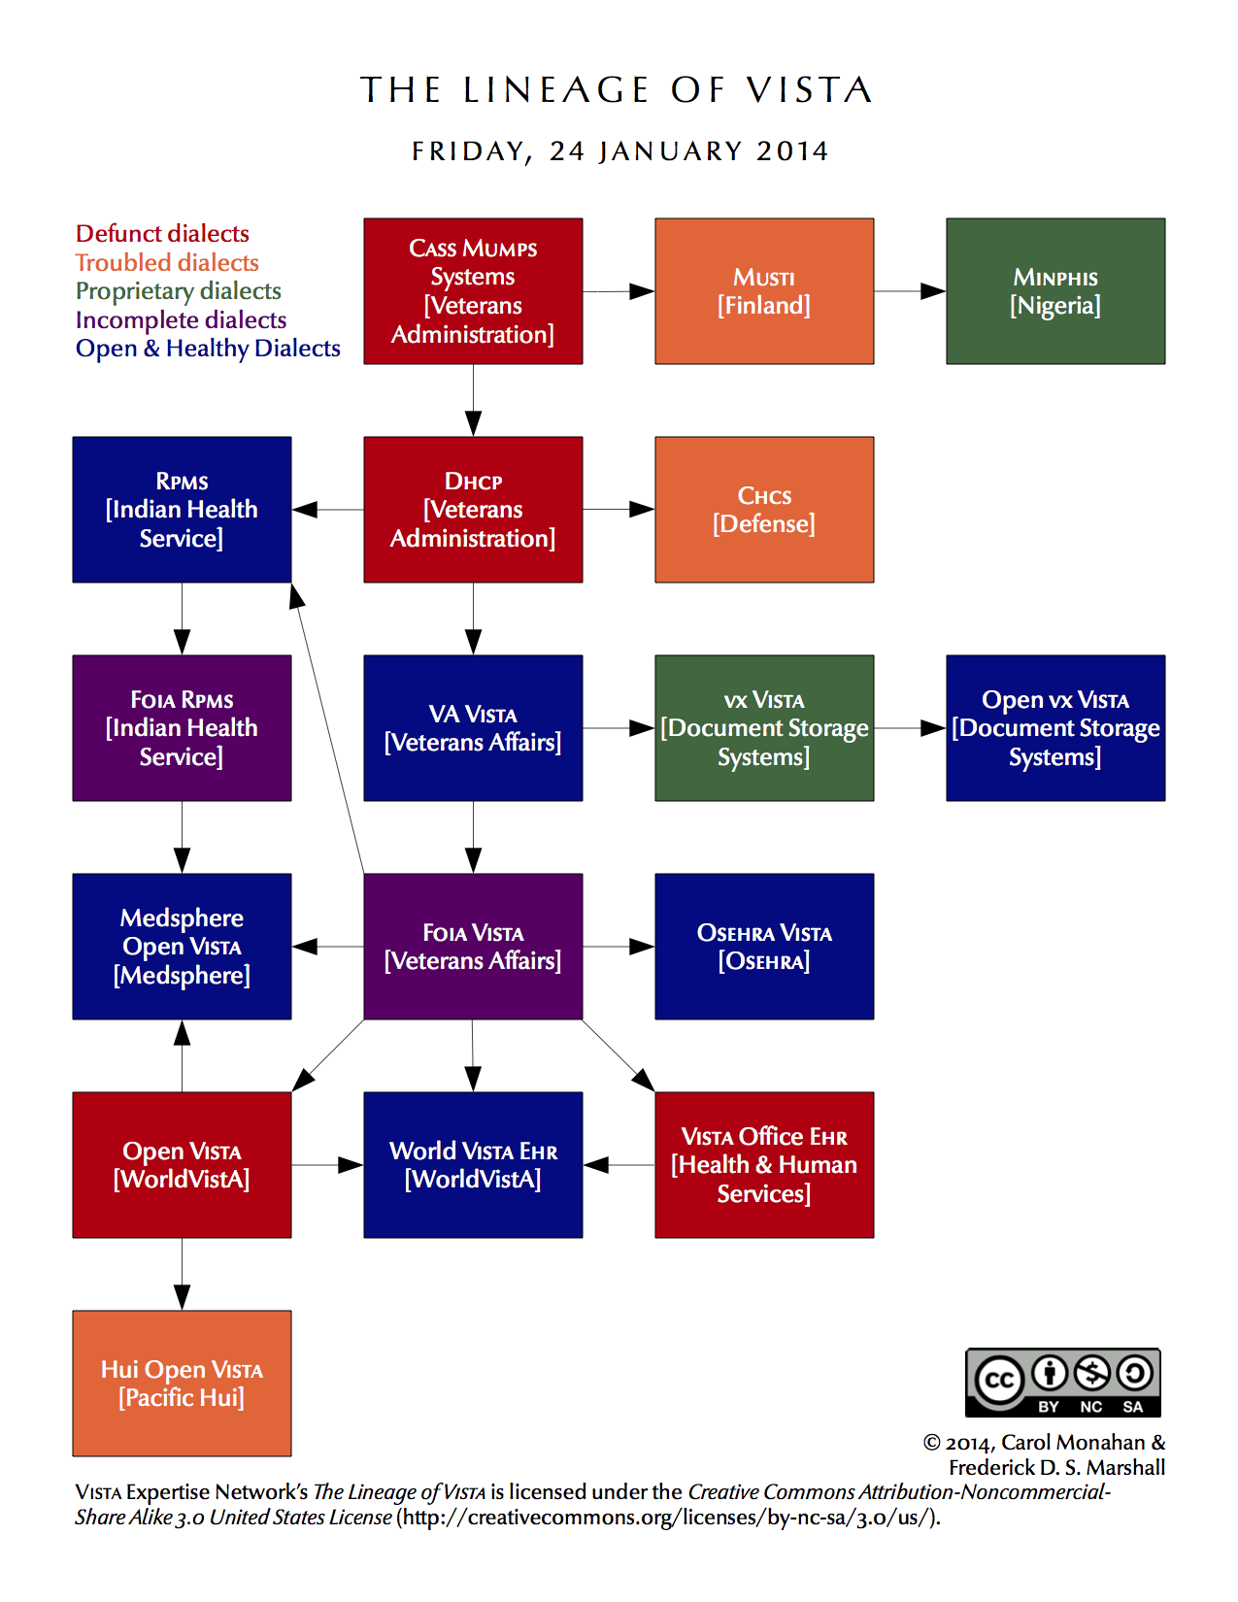

Glossary
Application An administrative division of VistA that automates part or all of one hospital or clinical service. Pharmacy and Nursing are examples of applications.
Application Version A complete new release of an application. Versions are numbered sequentially.
Build See KIDS Build
Checksum A number unique to any given version of a software element. Even a small change to the software will change the checksum, so checksums are used to detect changes and verify a particular version.
Dialect See VistA Dialect
Distribution See KIDS Distribution
FOIA Freedom of Information Act. The term “FOIA” can refer to the Act itself, or to a request sent to the government under the auspices of the Act.
Forum A VistA system used as the hub of an organization’s VistA software lifecycle. VA and OSEHRA each have their own Forums.
Gerrit A code-review system for use with a repository such as Github.
Git A version-control system.
Github A platform that hosts repositories using the Git system.
Host-File Format A file-based format for a KIDS distribution. It consists of two parts: the KIDS file and the text file.
KIDS The Kernel Installation and Distribution System. KIDS is the primary method for preparing a patch for the Patch Module, as well as the mechanism for installing patches.
KIDS Build The “manifest” of a KIDS distribution, which lists all the components included in the distribution.
KIDS Distribution A host file or Packman message containing a software update and associated tools and conversions for applying it.
KIDS File In a host-file format, the portion of the file containing the software.
KIDS Install A record describing what happened during each installation of a KIDS distribution at a specific site.
Local Modification A change to VistA made for a specific facility or organization. Local modifications are necessary in VistA, but result in changes to checksums that make version control more challenging.
Mailman VistA’s native email system. Patches can be distributed using Mailman’s Packman module.
Namespace A convention for naming VistA package elements. Each developer or organization is assigned a namespace, which is a unique character string, to be used use in naming routines, options, and other package elements. Namespacing helps keep similar elements from different developers distinct and easily identifiable.
Numberspace Similar to a namespace, a numberspace is a unique numeric string assigned to a developer or organization. Numberspaces are used for VistA elements that have numbers rather than names.
Package A distribution of a new version of an application.
Packman A module of Mailman used to ship patches and other software.
Packman Format A format for a KIDS distribution designed for use with Packman.
Packman Message Any email message that contains a KIDS distribution in Packman format.
Patch Any small change or update intended for installation in an active VistA system. Most patches can be installed with minimal disruption to the system or its users.
Patch Completer The developer who reviews the patch developer’s work, then updates the status of the patch in the Patch Module to “completed.”
Patch Developer Person who initially entered the information on the patch into the Patch Module. That person will be listed as the “developer” in the Patch Module, whether they did any actual development work or not.
Patch ID A multi-part identification number for a patch, which includes the application namespace, the application version number, and the patch number.
Patch Message An email message that contains a patch description and a Packman-format KIDS distribution. This is the default method for the Patch Module to distribute patches.
Patch Number Unique number given to a patch, as it relates to the specific application and version. Patch numbers are numberspaced, so patches from different sources can be immediately distinguished.
Patch Reviewer In secondary development, the developer who reviews the released patch to determine what kind of secondary development might be needed.
Patch Stream The series of patches developed and released for a specific application or dialect.
Patch Subscriber A person or organization who has signed up to receive a particular patch stream.
Patch Verifier Specialist who confirms that the patch is functionally complete, and meets all standards. Verifiers make the decision to release the patch.
Primary Developer The person or team who initiates the patching process and releases a new patch.
Primary Development The actions involved in creating and distributing a new patch.
Repository Online electronic storage which houses reference versions of a specific software. Generally, one version is designated as the “official” version. OSEHRA provides repositories for OSEHRA VistA and FOIA VistA.
Required Patch A prerequisite patch. All patches should list their required patches—that is, their prerequisites—for installation.
Secondary Developer The person or team who re-purposes a released patch for their VistA dialect.
Secondary Development The actions involved in re-purposing a patch for a different VistA dialect.
Sequence Number Unique number assigned when a patch is verified. It determines the default order in which patches should be installed.
Text File In host-file format, the portion of the file that contains the patch description.
Version See Application Version
Version Control A system or methodology for ensuring that all software within a given organization is the same version.
Version Number The sequential number of the current application version. Each VistA application has its own version number. For example, the current version of Laboratory is 5.2, while the current version of Fileman is 22.2.
VistA Dialect A unique, stable version of VistA supported by a specific vendor. Popular VistA dialects include OSEHRA VistA, vxVistA (Document Storage Systems), Medsphere Open VistAand WorldVistA EHR.
VistA Service Pack A bundle of VistA packages and patches, which can be used to upgrade an existing VistA system.
VistA Snapshot A copy of an existing VistA system. A VistA snapshot is most commonly used to clone a new VistA instance.

